Electronics Documentation

1. Electronics Block Diagram
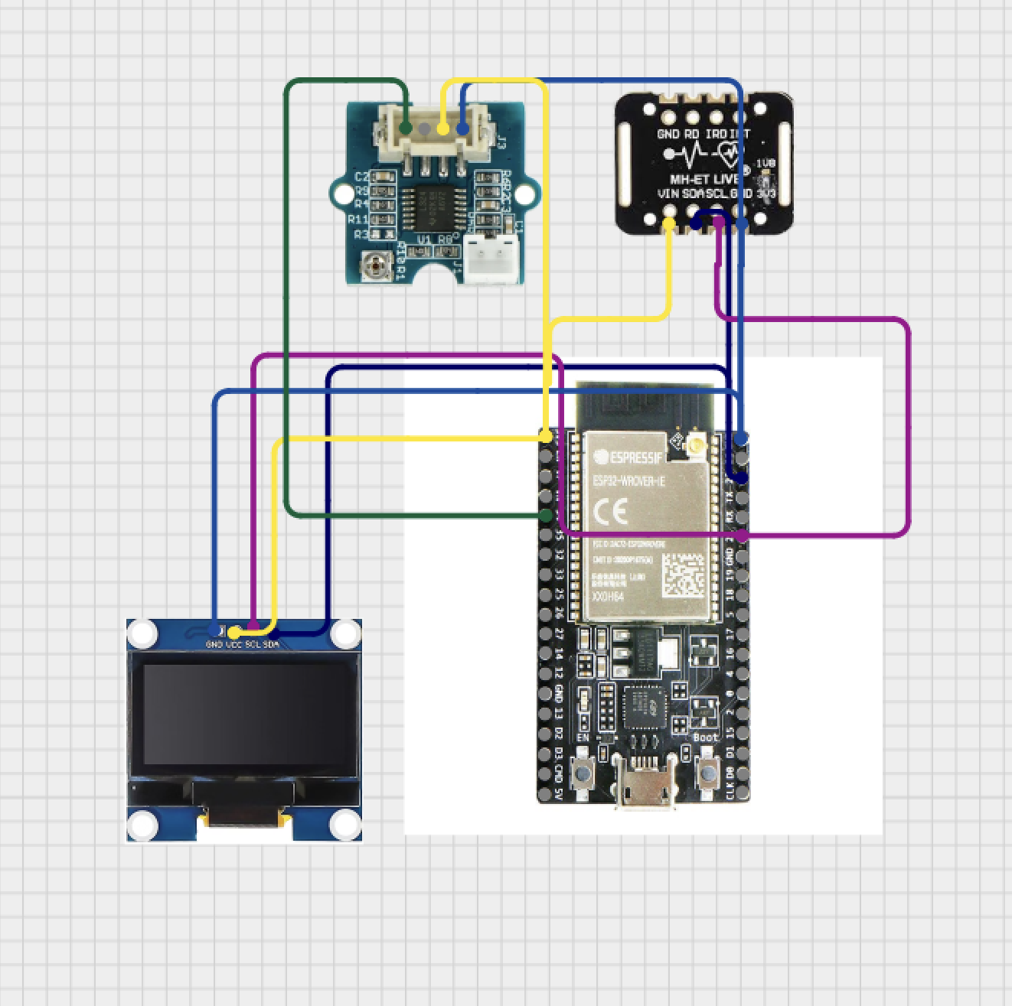

2. Components Table
Component | Quantity | Purpose | Justification
ESP32 | 1 | Main controller for the system | Chosen because it supports Bluetooth (BLE), has sufficient processing power for real-time data handling, and works well with MicroPython. It allows integration of sensors, display, and wireless communication in one device.
MAX30102 Sensor | 1 | Measures heart rate, pulse amplitude, and IR/Red signals | Used to detect cardiovascular changes under stress. It provides multiple physiological parameters (BPM, HRV, amplitude), making it more effective than a simple heart-rate sensor.
GSR Sensor | 1 | Measures skin conductivity (sweat response) | GSR is a key indicator of emotional arousal and stress, widely used in polygraph systems. It complements heart-rate data for better stress estimation.
SH1106 OLED Display (128×64) | 1 | Displays live data, waveform, prompts, and results | Provides real-time visual feedback directly on the device. Chosen for its compact size, clarity, and low power consumption, making it suitable for wearable use.
Bluetooth Low Energy (BLE) |  | Sends data to mobile app | Enables wireless communication with the phone. BLE is low power and ideal for wearable devices. Used to send live values and logs.
MIT App Inventor Mobile App | 1 | Displays and logs data from the device | Provides a simple interface for real-time monitoring and logging without requiring complex app development.
Breadboard | 2 | Prototyping and circuit connections | Used for easy assembly and testing. Allows quick changes during debugging and integration.
Jumper Wires |  | Connect all components | Essential for building the circuit. Flexible and reusable for rapid prototyping.
Power Source (USB / Battery) | 1 | Powers the ESP32 and components | Required for operation. USB used for development; battery suitable for wearable use.
Velcro Strap | 1 | Secures device to user’s hand | Chosen for adjustability and comfort. Works better than rigid designs for different users.
Cardboard Base | 1 | Holds components together physically | Used as a quick and stable prototyping structure after 3D printed design failed. Easy to modify and lightweight.

